## What are control statements?

It’s the order in which program’s code executes

Python has three types of control structures:

1. Sequential

Sequential statements are executed in order. If an error occurs in one line, it can disrupt the entire code's execution.

**a=20**

**b=10**

**c=a-b**

**print(“Subtraction is: “, c)**

1. 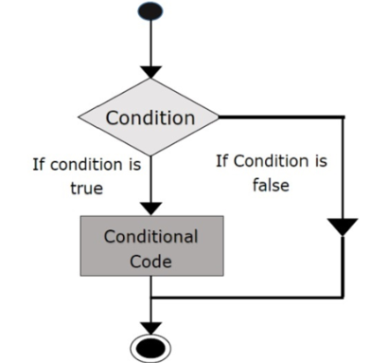Selection/Decision control statements

Python's selection statements, also called decision or branching statements, allow a program to evaluate multiple conditions and execute instructions based on the true condition. Types of decision control statements include:

* **Simple if**: A simple if statement checks one condition before executing specific code.

**n=10**

**if n % 2 == 0**

**print(“n is an even number”)**

* 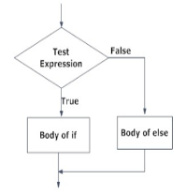**if-else**: The if-else statement in Python evaluates a condition. If the condition is true, it executes the body of the if block; if false, it executes the body of the else block.

**n=5**

**if n % 2 == 0**

**print(“n is even”)**

**else:**

**print(“n is odd”)**

* 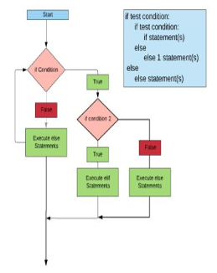**nested if** statements are an if statement inside another if statement.

**a=5**

**b=10**

**c=15**

**if a > b:**

**if a > c:**

**print(“a value is big”)**

**else:**

**print(“c value is big”)**

**elif b > c:**

**print(“b value is big”)**

**else:**

**print(“c is big”)**

* 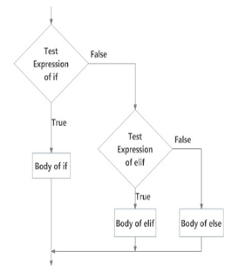**if-elif-else:** is used to conditionally execute a statement or a block of statements.

**x=15**

**Y=12**

**If x == y:**

**Print(“Both are Equal”)**

**elif x > y:**

**print(“x is greater than y”)**

**else:**

**print(“x is smaller than y”)**

1. A diagram of a condition

   Description automatically generatedRepetitions

Is used to repeat a group of instructions.

* **for loop**: It iterates over a sequence like a list, tuple, dictionary, or set. The statements inside the loop are executed for each item in the sequence.

**1st = [1,2,3,4,5]**

**for I in range(len(1st)):**

**print(1st[i], end = “ “)**

**for j in range(0,10):**

**print(j, end = “ “)**

* **A diagram of a diagram

  Description automatically generatedwhile loop**: This type of loop executes a block of statements repeatedly as long as a specified condition is met. The condition is checked before each iteration, and the loop continues until the condition is false.

**m=5**

**i=0**

**while I < m:**

**print(I, end = “ “)**

**i=i+1**

**print(“End”)**